

**Semester 1 Examination 2012**

**Question/Answer Booklet**

**MATHEMATICS 3CD**

**Section One:**

**Calculator-free**

Name of Student: ______________________________________________

Name of Teacher ______________________________________________

**Time allowed for this section**

Reading time before commencing work: 5 minutes

Working time for this section: 50 minutes

**Materials required/recommended for this section**

***To be provided by the supervisor***

This Question/Answer Booklet

Formula Sheet

***To be provided by the student***

Standard items: pens, pencils, pencil sharpener, eraser, correction fluid/tape, ruler,

highlighters

Special items: nil

**Important note to students**

No other items may be used in this section of the examination. It is **your** responsibility to ensure

that you do not have any unauthorised notes or other items in the examination room. If you have any unauthorised material with you, hand it to the supervisor **before** reading any further.

**Structure of this paper**

|  |  |  |  |  |  |
| --- | --- | --- | --- | --- | --- |
| Section | Number of questions available | Number of questions to be answered | Working time  (minutes) | Marks available | Percentage of exam |
| Section One  Calculator-free | 6 | 6 | 50 | 50 |  |
| Section Two  Calculator-assumed | 12 | 12 | 100 | 100 |  |

|  |  |  |
| --- | --- | --- |
| Total | 150 | 100 |

**Instructions to students**

1 Write your answers in the spaces provided in this Question/Answer Booklet. Spare pages are included at the end of this booklet. They can be used for planning your responses and/or as additional space if required to continue an answer. If you need to use the space to continue an answer, indicate in the original answer space where the answer is continued. i.e. give the page number. Fill in the number of the question(s) that you are continuing to answer at the top of the page.

2 **Show all your working clearly**. Your working should be in sufficient detail to allow your answers to be checked readily and for marks to be awarded for reasoning. Incorrect answers given without supporting reasoning cannot be allocated any marks. For any question or part question worth more than two marks, valid working or justification is required to receive full marks. If you repeat an answer to any question, ensure that you cancel the answer you do not wish to have marked.

3 It is recommended that you **do not use pencil**, except in diagrams.

**Section One: Calculator-free (50 marks)**

This section has **six (6)** questions. Answer all questions. Write your answers in the spaces provided.

Working time: 50 minutes

_________________________________________________________________________________

**Question 1 (8 marks)**

(a) Given the following Venn Diagram showing events A and B

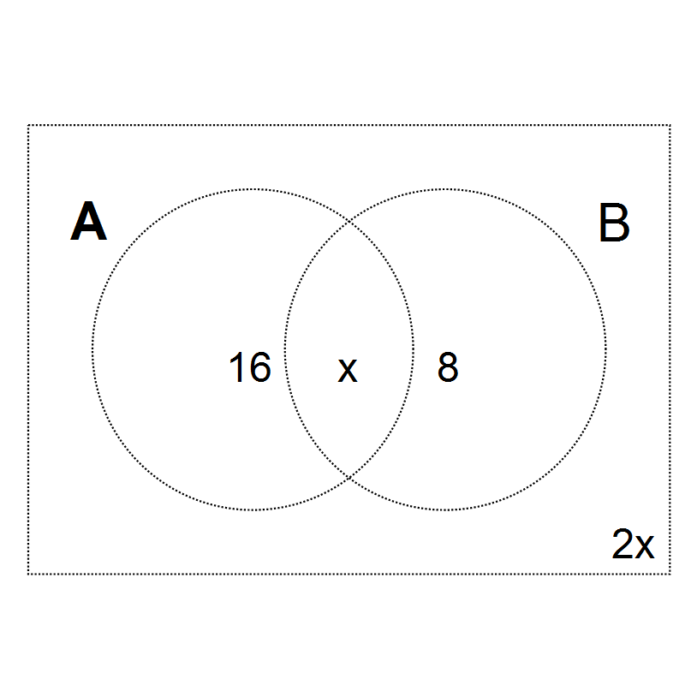

Determine x if

1. A and B are mutually exclusive (1)
2. A and B are independent. (The condition from (i) does not necessarily hold)

(3)

(b) The functions and are defined as follows

and 

(i) Determine expressions for . (2)

(ii) Determine the range of . (1)

(iii) Determine the domain of . (1)

**Question 2 (9 marks)**

(a) Differentiate the following with respect to *x.*

1.  (express in simplest form) (3)
2.  (do not simplify) (2)

(b) Sketch the graph of the derivative function for on the axes below. (2)





**Question 2 (continued)**

(c) Given the derivative function, sketch the graph of the function. (2)





**Question 3 (7 marks)**

(a) It is claimed that the tangent to the curve  at the point where *x*=1 passes through the point (3,8). Is this claim valid? Justify your answer. (5)

(b) Two identical biased coins are tossed together, and the outcome is recorded. After a large number of trials it is observed that the probability that both coins land showing heads is 0.36.

What is the probability that both coins land showing tails? (2)

**Question 4 (8 marks)**

The volume of a certain rectangular box is given by the equation .

(i) If the height of the box is units, determine an algebraic expression for the area of the base of the box. (3)

(ii) Calculate the value of *x* for which the volume is a maximum. (5)

**Question 5 (10 marks)**

(a) A spherical balloon is being deflated in such a way that the volume is decreasing at a constant rate of 120cm3/sec. At time *t* (seconds), the radius of the balloon is *r* cm.

Find the rate of change of the surface area when the volume is cm3. (5)

**Question 5 (continued)**

(b) Events *A* and *B* are such ,  and 

1. Show that event *A* and *B* are **NOT** mutually exclusive. (3)
2. Hence find . (2)

**Question 6 (8 marks)**

(a) Determine  (2)

(b) Determine  (2)

(c)  is defined such that  and 

Find

1. . (2)

**Question 6 (continued)**

(c) (ii)  (2)